LECTURE 3
CLASSICAL ENCRYPTION

1. Origin and Definition of Cryptography
Cryptography is the science of protecting information by converting it into a form that unauthorized people cannot understand.
The word cryptography comes from Greek:
- kryptós → hidden
- gráfein → to write
So, cryptography literally means “hidden writing.”
In cryptography:
- A readable message is called plaintext
- The unreadable (coded) form is called ciphertext
Cryptography involves:
- Encrypting the plaintext into ciphertext before sending
- Decrypting the ciphertext back into plaintext at the receiver side
The main purpose of cryptography is to:
- Protect data from unauthorized access
- Ensure secure communication over insecure networks (like the Internet)

2. Security Concepts in Cryptography
2.1 Unconditional (Information-Theoretic) Security
A cryptosystem is said to have unconditional security if it cannot be broken, no matter:
- how much computing power is available
- how much time the attacker has
In this case:
- The ciphertext does not give enough information to uniquely determine the plaintext
- Security does not depend on computational power
Example:
One-Time Pad (OTP) — when the key is truly random and as long as the message.
2.2 Computational Security
A cryptosystem has computational security if:
- It can be broken theoretically
- But breaking it is not practical due to extremely large time or resource requirements
This means:
- Even if the attacker knows the algorithm
- The time required to break the cipher is greater than practical limits (e.g., age of the universe)
Most modern cryptographic systems rely on computational security, not unconditional security.

3. Basic Cryptographic Terminology
Plaintext
The original, readable message before encryption.
Example:
HELLO WORLD
Ciphertext
The encrypted, unreadable message after encryption.
Example:
KHOOR ZRUOG
Cipher
A method or algorithm used to convert plaintext into ciphertext and ciphertext back into plaintext.
Key
A secret piece of information used by the cipher for encryption and decryption.
Only authorized sender and receiver know the key.
Encryption (Enciphering)
The process of converting plaintext into ciphertext using a cipher and a key.
Decryption (Deciphering)
The process of converting ciphertext back into plaintext using a cipher and a key.
Cryptography
The study of designing secure encryption techniques.
Cryptanalysis
The study of breaking encryption, i.e., recovering plaintext or key without knowing the secret key.
Cryptology
The combined field of cryptography and cryptanalysis.

4. Classification of Ciphers
Ciphers can be classified based on how keys are used and how data is encrypted.
The two main categories are:
- Symmetric Ciphers
- Asymmetric Ciphers
4.1 Symmetric Ciphers
In symmetric ciphers, the same key is used for:
- encryption by the sender
- decryption by the receiver
Key points:
- Sender and receiver must share the secret key beforehand
- All classical encryption techniques are symmetric
- Symmetric ciphers are fast and efficient
Symmetric ciphers are further divided based on how they process data.
4.1.1 Block Ciphers
A block cipher encrypts plaintext in fixed-size blocks.
Key characteristics:
- Plaintext is divided into blocks (typically 64 bits or 128 bits)
- Each block is encrypted independently using the same key
- If plaintext size is larger than the block size, it is split into multiple blocks
Example:
- DES (64-bit block size)
- AES (128-bit block size)
Block ciphers are mainly used when:
- Data size is large
- High security is required
4.1.2 Stream Ciphers
A stream cipher encrypts data one bit or one byte at a time.
Key characteristics:
- Encryption is done continuously
- Uses a keystream generated from the secret key
- Each plaintext bit is combined with a keystream bit
Example:
- RC4
- Vernam cipher (One-Time Pad)
Stream ciphers are mainly used when:
- Data is transmitted in real time
- Speed is more important than block processing
4.2 Asymmetric Ciphers
In asymmetric ciphers, two different keys are used:
- Public key for encryption
- Private key for decryption
Key points:
- Public key is shared openly
- Private key is kept secret
- Solves the key distribution problem of symmetric ciphers
- Introduced in the 1970s
Examples:
- RSA
- Diffie–Hellman
- ECC

5. Symmetric Encryption Model
The symmetric encryption model describes how secure communication happens using a shared secret key.
Basic components:
- Sender
- Receiver
- Plaintext
- Ciphertext
- Encryption algorithm
- Decryption algorithm
- Secret key
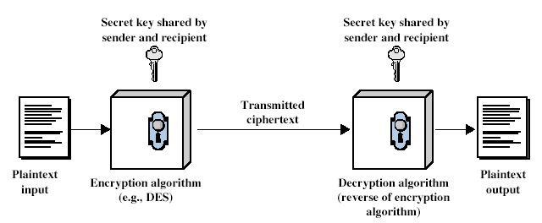
5.1 Explanation of the Symmetric Encryption Model (Diagram)
This diagram shows how secure communication happens using a shared secret key.
1. Plaintext Input (Sender Side)
- On the left, we have the plaintext input
- This is the original readable message
- Example:
HELLO, ATTACK AT DAWN, etc.
This plaintext is not secure, so it cannot be sent directly.
2. Encryption Algorithm
- The plaintext is given to an encryption algorithm
- Example shown in the diagram: DES
- The encryption algorithm:
  - is publicly known
  - uses a secret key to encrypt the message
3. Secret Key (Shared Key)
- The same secret key is:
  - known to the sender
  - known to the receiver
- This key is never sent with the message
- Security depends on keeping this key secret
This is why it is called symmetric encryption — both sides use the same key.
4. Ciphertext (During Transmission)
- After encryption, plaintext becomes ciphertext
- Ciphertext is:
  - unreadable
  - safe to send over an insecure channel (like the Internet)
Even if an attacker intercepts it, they cannot understand it without the key.
5. Decryption Algorithm (Receiver Side)
- The ciphertext reaches the receiver
- The receiver applies the decryption algorithm
- The decryption algorithm is:
  - the reverse of the encryption algorithm
  - uses the same secret key
6. Plaintext Output (Receiver Side)
- After decryption:
  - the original plaintext is recovered
- The receiver gets the exact original message sent by the sender

5.2 Mathematical Representation of Symmetric Encryption
Let:
- X = plaintext
- Y = ciphertext
- K = secret key
- E = encryption algorithm
- D = decryption algorithm
Encryption:
- Y = E(K, X)
Decryption:
- X = D(K, Y)
Key points:
- Same key K is used in both encryption and decryption
- Algorithms E and D are known to everyone
- Security relies entirely on the secrecy of K

6. Cryptanalysis Fundamentals
Cryptanalysis is the study of techniques used to break cryptographic systems.
The attacker (cryptanalyst) tries to:
- read the encrypted message
- or find the secret key
without knowing the key
6.1 Objectives of Cryptanalysis
The main objectives of cryptanalysis are:
- Recover the plaintext from the ciphertext
- Recover the secret key used in encryption
- Break the cryptosystem with minimum time and effort
In practice, recovering the key is more valuable than recovering just one message.
6.2 Kerckhoffs’s Principle
Kerckhoffs’s Principle states that:
A cryptosystem should remain secure even if everything about the system is public, except the secret key.
Key ideas:
- The attacker knows the algorithm
- The attacker does not know the key
- Security must depend only on the secrecy of the key
Modern cryptography fully follows this principle.
6.3 Types of Attacks
Cryptanalytic attacks are broadly divided into two categories:
- Brute-Force Attacks
- Cryptanalytic (Non–Brute-Force) Attacks
6.3.1 Brute-Force Attacks
In a brute-force attack:
- The attacker tries every possible key
- Each key is tested until meaningful plaintext appears
Key points:
- Guaranteed to work eventually
- Time required depends on key size
- No knowledge of language or algorithm weaknesses needed
6.3.2 Cryptanalytic (Non–Brute-Force) Attacks
In cryptanalytic attacks:
- The attacker does not try all keys
- Instead, exploits weaknesses in the cipher
These attacks use:
- Mathematical properties
- Language statistics
- Patterns in plaintext and ciphertext
Examples:
- Frequency analysis
- Known-plaintext attacks
- Chosen-plaintext attacks
These attacks are much faster than brute-force attacks when successful.

7. Brute-Force Attacks
A brute-force attack is the simplest and most direct attack on a cipher.
The attacker:
- Systematically tries all possible keys
- Decrypts the ciphertext using each key
- Checks whether the output makes sense
7.1 Key Space and Search Complexity
Key space is the total number of possible keys.
Key points:
- Larger key space → higher security
- On average, attacker must try half of the key space
Example:
- 8-bit key → 2⁸ = 256 keys
- 56-bit key (DES) → 2⁵⁶ keys
Search complexity increases exponentially with key length.
7.2 Time Requirements and Practical Feasibility
The time required for brute-force attack depends on:
- Key size
- Speed of available hardware
If:
- Time required > practical limits
→ the cipher is considered computationally secure
Example:
- If breaking a cipher takes longer than the age of the universe, it is practically secure.

8. Symmetric Cipher Categories
Symmetric ciphers are categorized based on how encryption is performed.
They are divided into:
- Classical Symmetric Ciphers
- Modern Symmetric Ciphers
8.1 Classical Symmetric Ciphers
Classical ciphers were used before modern computers.
They are simple and mainly operate on:
- letters
- characters
8.1.1 Substitution Ciphers
In substitution ciphers:
- Each element of plaintext is replaced with another element
Example:
- Caesar cipher
- Monoalphabetic substitution
Order of characters does not change.
8.1.2 Transposition Ciphers
In transposition ciphers:
- Plaintext characters are rearranged
- Characters themselves are not changed
Example:
- Rail fence cipher
- Columnar transposition
8.1.3 Product Ciphers
Product ciphers:
- Use multiple stages of substitution and transposition
- Provide stronger security than single-step ciphers
Modern ciphers are essentially product ciphers.
8.2 Modern Symmetric Ciphers
Modern ciphers are designed for computer-based encryption.
They operate on:
- bits rather than characters
- large key sizes
8.2.1 Feistel Ciphers
Feistel ciphers:
- Divide plaintext block into two halves
- Apply multiple rounds of processing
- Same structure is used for encryption and decryption
Example:
- DES
8.2.2 Non-Feistel Ciphers
Non-Feistel ciphers:
- Do not use Feistel structure
- Encryption and decryption processes are different
Example:
- AES

9. Classical Encryption Operations
In classical cryptography, plaintext is treated as a sequence of elements such as:
- letters
- characters
- bits
Classical encryption works using basic operations applied to these elements.
9.1 Substitution Operation
In a substitution operation:
- Each element of plaintext is replaced by another element
- The position/order of elements remains the same
Key points:
- Replacement is done according to a rule or key
- Same plaintext symbol may map to:
  - same ciphertext symbol (monoalphabetic)
  - different ciphertext symbols (polyalphabetic / homophonic)
Example:
- A → D
- B → E
- HELLO → KHOOR
9.2 Transposition Operation
In a transposition operation:
- The order of plaintext elements is rearranged
- The actual elements do not change
Key points:
- No substitution takes place
- Only positions are changed
Example:
- Plaintext: ATTACK
- Transposed: TTAACK
Security comes from confusing the positions of characters.
9.3 Product Cipher Concept
A product cipher:
- Uses multiple encryption steps
- Combines substitution and transposition
Key points:
- Each individual step may be weak
- Combined steps provide stronger security
Modern encryption algorithms (like DES and AES) are based on product cipher concepts.

10. Classical Substitution Ciphers
10.1 Overview and Characteristics
Classical substitution ciphers:
- Replace plaintext symbols with ciphertext symbols
- Are easy to understand
- Were widely used before computers
Characteristics:
- Simple rules
- Vulnerable to statistical analysis
- Operate mainly on letters
10.2 Types of Substitution Ciphers
Based on how substitutions are applied, substitution ciphers are classified into different types.
10.2.1 Monoalphabetic Ciphers
In monoalphabetic ciphers:
- Each plaintext letter is replaced by one fixed ciphertext letter
- Same mapping is used throughout the message
Key points:
- Simple substitution
- Large key space (26!)
- Weak against frequency analysis
Examples:
- Caesar cipher
- Simple substitution cipher
10.2.2 Homophonic Ciphers
In homophonic ciphers:
- A single plaintext letter can map to multiple ciphertext symbols
- Choice of ciphertext symbol is random or rotated
Purpose:
- To hide letter frequency patterns
Key points:
- Reduces effectiveness of frequency analysis
- Digram and trigram patterns may still exist
Examples:
- Book cipher
- Beale cipher
- Straddling checkerboard
10.2.3 Polyalphabetic Ciphers
In polyalphabetic ciphers:
- A plaintext letter can map to different ciphertext letters
- Multiple substitution alphabets are used
Key points:
- Controlled by a key
- Same plaintext letter encrypted with different key letters gives different ciphertext
Examples:
- Vigenère cipher
- Autokey cipher
- Beaufort cipher
10.2.4 Polygram Ciphers
In polygram ciphers:
- Substitution is applied to groups of letters instead of single letters
Key points:
- Operate on digrams or trigrams
- More secure than single-letter substitution
Example:
- Playfair cipher (digram-based)

11. Monoalphabetic Substitution Ciphers
A monoalphabetic substitution cipher is a cipher in which:
- Each plaintext letter is replaced by one fixed ciphertext letter
- The same substitution is used throughout the entire message
Key idea:
One plaintext alphabet → one ciphertext alphabet
11.1 Simple Substitution Concept
In a simple substitution cipher:
- Letters are substituted individually
- Each plaintext letter maps to exactly one ciphertext letter
Example mapping:
Plain : A B C D E F G ...
Cipher: Q W E R T Y U ...
Example:
- Plaintext: HELLO
- Ciphertext: ITSSG
Characteristics:
- Easy to implement
- Large number of possible keys
- Weak against statistical attacks
11.2 Substitution Alphabets
A substitution alphabet is the mapping between:
- plaintext letters
- ciphertext letters
Types of substitution alphabets:
- Shifted alphabet
  - Letters are shifted by a fixed number
  - Example: Caesar cipher
- Reversed alphabet
  - Alphabet is reversed
  - Example: Atbash cipher
- Mixed (Deranged) alphabet
  - Letters are randomly scrambled
  - Used in general monoalphabetic ciphers
11.3 Caesar Cipher
The Caesar cipher is the earliest known substitution cipher.
It replaces each letter with the letter that is a fixed number of positions ahead in the alphabet.
11.3.1 Historical Background
- Invented by Julius Caesar
- Used for military communication
- Shift value used by Caesar: 3
Example:
Plain : A B C D E F ...
Cipher: D E F G H I ...
11.3.2 Encryption and Decryption Method
Encryption:
- Replace each plaintext letter by shifting it k positions forward
Example (k = 3):
- ATTACK → DWWDFN
Decryption:
- Shift each ciphertext letter k positions backward
- Reverse process of encryption
11.3.3 Mathematical Representation of Caesar Cipher (with Example)
To represent the Caesar cipher mathematically, we first convert letters into numbers.
Step 1: Letter–Number Mapping
Each letter is mapped as:
a → 0
b → 1
c → 2
...
z → 25
Step 2: Encryption Formula
The encryption of a plaintext letter p using key k is:
$$c=E_{k}(p)=(p+k) mod 26$$
Where:
- p = plaintext letter (number form)
- k = key (shift value)
- c = ciphertext letter (number form)
- mod 26 ensures the result stays within 0–25
Step 3: Decryption Formula
The decryption of a ciphertext letter c is:
$$p=D_{k}(c)=(c-k) mod 26$$
Worked Example (Very Important)
Given:
- Plaintext = ATTACK
- Key = k = 3
Step 4: Convert Plaintext to Numbers
A → 0
T → 19
T → 19
A → 0
C → 2
K → 10

Step 5: Apply Encryption Formula
$$c=(p+3) mod 26$$
Plain (p) | Number | Calculation | Cipher Number | Cipher
A | 0 | (0 + 3) mod 26 | 3 | D
T | 19 | (19 + 3) mod 26 | 22 | W
T | 19 | (19 + 3) mod 26 | 22 | W
A | 0 | (0 + 3) mod 26 | 3 | D
C | 2 | (2 + 3) mod 26 | 5 | F
K | 10 | (10 + 3) mod 26 | 13 | N

Final Ciphertext
ATTACK → DWWDFN
Decryption Check (Quick)
Take D:
- D → 3
$$p=(3-3) mod 26=0→A$$
So decryption correctly recovers the original plaintext.
11.4 Cryptanalysis of Caesar Cipher
Cryptanalysis of the Caesar cipher means breaking the cipher without knowing the key.
The Caesar cipher is one of the weakest encryption techniques because:
- It uses a very small key space
- It preserves language characteristics
- It is highly vulnerable to brute-force attacks
Why Caesar Cipher Is Easy to Break
- The number of possible keys is very small
- Each key produces readable text
- Human language patterns remain visible after encryption
Because of these reasons, no advanced cryptanalytic techniques are required.
11.4.1 Key Space Analysis
- Caesar cipher uses a shift key k
- Possible values of k:
- k ∈ {0, 1, 2, ..., 25}
- Total number of keys = 26
Key space is extremely small. On average, an attacker needs to try 13 keys to find the correct one.
11.4.2 Vulnerability to Brute-Force Attacks
In a brute-force attack on Caesar cipher:
- Attacker tries all possible shifts
- Each decryption attempt produces a readable output
- The correct plaintext is easily recognized
Example:
Shift 1 → GSSZBJ
Shift 2 → FTTYAI
Shift 3 → ATTACK ✔
Because:
- Natural language is easy to recognize
- Only 25 meaningful attempts are needed
Caesar cipher offers no real security.
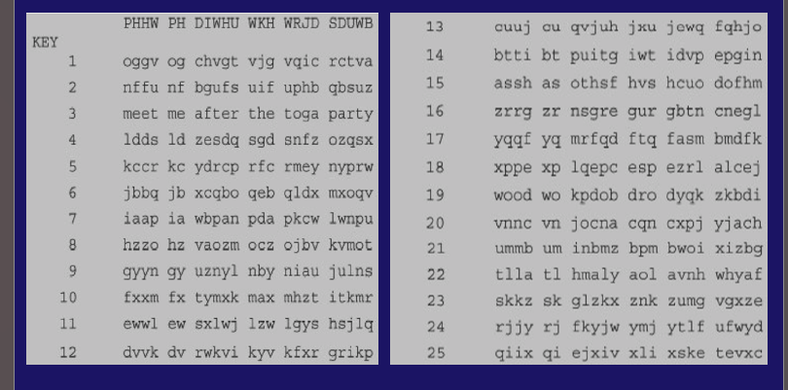
What This Table Shows
This table shows all possible keys of the Caesar cipher and the resulting decrypted plaintext for each key.
- Caesar cipher has 25 possible meaningful keys
- Each key = one shift value
- The table lists:
  - Key number (shift value)
  - Decrypted text using that key
12. General Monoalphabetic Cipher Security
A general monoalphabetic cipher uses a fixed substitution between:
- the plaintext alphabet (top row)
- the ciphertext alphabet (bottom row)
The mapping is one-to-one and stays the same for the entire message.
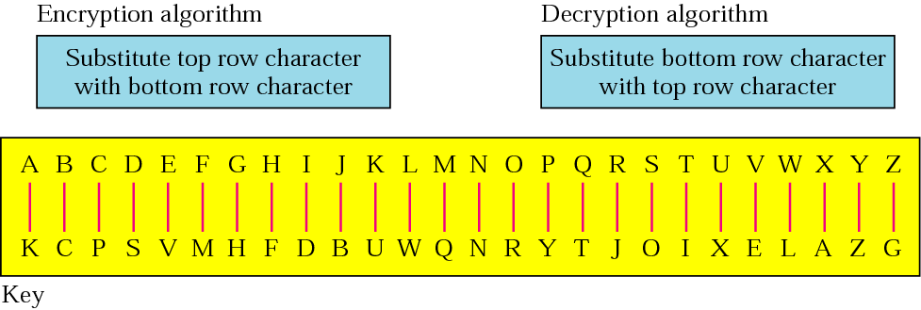
Example:
1) pt : larger key size means greater security
CT : WKJHV JUVZO DGVQV KNOHJ VKIVJ OVPXJ DIZ
2) CT: SVOIJ RZIFV UVZKI IFVVN SRMIF VOVOO DRN
pt : destroy the key at the end of the session
Understanding the Picture (Very Important)
Top Row (Plaintext Alphabet)
A B C D E F G H I J K L M N O P Q R S T U V W X Y Z
Bottom Row (Ciphertext Alphabet – the KEY)
K C P S V M H F D B U W Q N R Y T J O I X E L A Z G
Encryption (Left Box in Picture)
“Substitute top row character with bottom row character”
That means:
- A → K
- B → C
- C → P
- D → S
- … and so on
Example:
Plaintext: BAD
Ciphertext: C K S
Decryption (Right Box in Picture)
“Substitute bottom row character with top row character”
That means:
- K → A
- C → B
- P → C
- S → D
So decryption is just the reverse lookup.
12.1 Key Space Size (26!)
In a general monoalphabetic cipher:
- Any letter can map to any other letter
- No two plaintext letters can map to the same ciphertext letter
So the number of possible keys is:
$$26!=26×25×24×⋯×1$$
Value:
$$26!≈4×{10}^{26}$$
What This Means
- The key space is extremely large
- Brute-force attack is not practical
- Much stronger than Caesar cipher (which has only 26 keys)
Against brute-force attacks, monoalphabetic ciphers look secure.
12.2 Weakness Against Statistical Attacks
Despite the huge key space, monoalphabetic ciphers are not secure.
Why?
Because:
- The substitution is fixed
- Language characteristics are preserved
Language Statistics Leak Through
In English:
- E appears most frequently
- Followed by T, A, O, I, N
- Rare letters: Z, Q, X, J
Since substitution is fixed:
- Most frequent ciphertext letter ≈ E
- Common digrams like TH, HE
- Common trigrams like THE, AND
The picture shows a fixed mapping, which means:
Relative letter frequencies do not change
Result
An attacker can:
- Count ciphertext letter frequencies
- Compare them with known English frequencies
- Guess mappings
- Refine guesses using digrams and trigrams
This is called frequency analysis.

13. Language Statistics and Cryptanalysis
Language statistics play a central role in breaking classical substitution ciphers.
This topic explains why monoalphabetic ciphers are insecure despite a large key space.
13.1 Human Language Is Not Random
Natural languages follow fixed statistical patterns:
- Letters do not appear with equal probability
- Certain letter combinations occur frequently
- Some patterns almost never occur
This non-randomness is exploited in cryptanalysis.
13.2 Single-Letter Frequency Statistics (Monograms)
Each letter in English appears with a different relative frequency.
This is shown in the given frequency graph.
Key observations:
- E is the most frequent letter (~12.7%)
- T is the second most frequent
- A, O, I, N, R, S are common
- Q, X, Z, J are rare
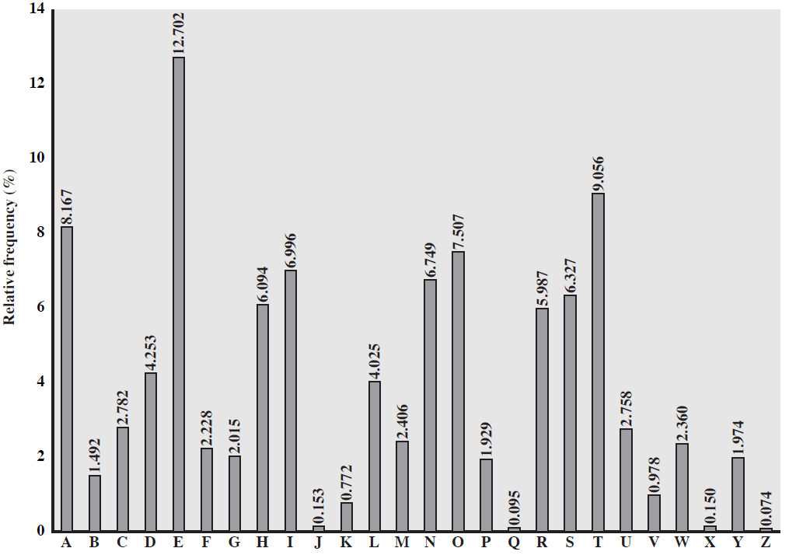
This graph represents monogram statistics only.
13.3 Digram Frequency Statistics
A digram is a sequence of two letters.
Common English digrams:
TH, HE, IN, ER, AN, RE, ON
Important points:
- Some digrams occur very frequently
- Some combinations almost never occur (e.g., QZ, JX)
Digram patterns remain visible in monoalphabetic substitution.
13.4 Trigram Frequency Statistics
A trigram is a sequence of three letters.
Common English trigrams:
THE, AND, ING, ION, TIO
Trigrams:
- Help confirm earlier guesses
- Reduce ambiguity in cryptanalysis
13.5 Use of Language Statistics in Cryptanalysis
In monoalphabetic ciphers:
- Letter substitution is fixed
- Frequencies are preserved
Attack process:
- Count ciphertext letter frequencies
- Compare with known English frequencies (graph)
- Guess mappings (E, T, A, O)
- Use digram analysis (TH, HE)
- Use trigram analysis (THE, AND)
- Refine guesses until plaintext appears
13.6 Why Monoalphabetic Ciphers Fail
Even though:
- Key space = 26!
They are insecure because:
- Fixed substitution leaks language structure
- Statistical patterns survive encryption
13.7 Example of Frequency-Based Cryptanalysis
This example shows how a monoalphabetic substitution cipher is broken using letter-frequency analysis.
Given Ciphertext
UZQSOVUOHXMOPVGPOZPEVSGZWSZOPFPESXUDBMETSXAIZ
VUEPHZHMDZSHZOWSFPAPPDTSVPQUZWYMXUZUHSXEPYEP
OPDZSZUFPOMBZWPFUPZHMDJUDTMOHMQ
The goal is to recover the plaintext without knowing the key.
Step 1: Count Letter Frequencies
- Count how many times each letter appears in the ciphertext
- Identify the most frequent letters
Observation:
- Z and P appear very frequently
From English statistics:
- Most common letters → E and T
So we guess:
Z → E
P → T
Step 2: Look for Common Trigrams
In English, the most common trigram is:
THE
In the ciphertext, the pattern ZWP appears frequently.
Using our guesses:
Z → E
W → H
P → T
So:
ZWP → THE
This confirms:
W → H
Step 3: Apply Partial Substitution
After applying known substitutions, parts of plaintext start appearing.
For example:
ZWPES → THE?S
This likely represents:
THERE or THESE
Using context, further mappings are guessed.
Step 4: Use Digram Patterns
Common English digrams:
TH, HE, IN, ER, AN
Match these against ciphertext patterns and:
- Fill in more letter mappings
- Remove incorrect guesses
Step 5: Trial and Error Refinement
- Replace guessed letters
- Check if resulting text forms meaningful English
- Adjust mappings if inconsistencies appear
Gradually, the entire plaintext is recovered.
Final Decrypted Plaintext
IT WAS DISCLOSED YESTERDAY THAT SEVERAL INFORMAL BUT DIRECT CONTACTS
HAVE BEEN MADE WITH POLITICAL REPRESENTATIVES OF THE VIET CONG IN MOSCOW
Why This Attack Works
- Monoalphabetic substitution uses fixed mapping
- Letter frequencies are preserved
- English language structure leaks through encryption
14. Homophonic Substitution Ciphers
14.1 Concept and Motivation
A homophonic substitution cipher is a substitution cipher in which:
One plaintext letter can be represented by multiple different ciphertext symbols.
Motivation
Monoalphabetic ciphers fail because:
- Each letter always maps to one symbol
- Letter frequency patterns remain visible
Homophonic ciphers were designed to:
- Flatten letter frequencies
- Hide the fact that letters like E, T, A occur more often
14.2 Encryption Method
Key Idea
- High-frequency letters are assigned many ciphertext symbols
- Low-frequency letters are assigned few symbols
During encryption:
- Take a plaintext letter
- Choose any one of its assigned symbols (randomly or by rule)
- Write that symbol as ciphertext
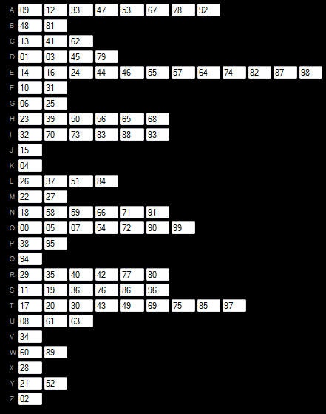
Explaining the Given Picture (IMPORTANT)
In the image:
- Each letter (A–Z) has a set of numbers
- These numbers are the homophones for that letter
Example from the picture:
- E → 14, 16, 24, 44, 46, 55, 57, 64, 74, 82, 87, 98
(many values because E is very frequent)
- Q → 94
(only one value because Q is rare)
- T → 17, 20, 30, 43, 49, 69, 75, 85, 97
(many values)
Example Encryption Using the Picture
Plaintext:
MEET
Possible encryption:
M → 22
E → 57
E → 16
T → 75
Ciphertext:
22 57 16 75
Notice:
- Same letter E encrypted differently each time
- Frequency pattern is hidden
14.3 Resistance to Frequency Analysis
Homophonic substitution defeats simple frequency analysis because:
- Frequent letters are split across many symbols
- Ciphertext symbol frequencies become uniform
- No single symbol dominates the ciphertext
Result:
Attackers cannot directly guess E, T, A using frequency counts.
14.4 Limitations and Residual Patterns
Despite improvement, homophonic ciphers are not perfectly secure.
Limitations:
- Digram and trigram patterns may still leak
- Contextual guessing can still work
- Large keys are difficult to manage
- Manual encryption is slow and error-prone
Important Point
Homophonic substitution increases security but does not make classical ciphers unbreakable.
14.5 Book Cipher
A book cipher is a cipher in which:
- The key is a shared book or written text
- Ciphertext symbols are numbers that point to positions in the book
(page, line, word, or word number)
The plaintext is usually obtained from:
- The first letter of the referenced word (sometimes the whole word)
Why it is homophonic:
Since the same letter appears many times in a book, one plaintext letter can be represented by many different numbers, hiding letter frequencies.
Advantages:
- Very large key space
- Difficult to break without the exact book
Limitations:
- Both sender and receiver must use the same edition
- Slow and impractical for long messages
How It Works
The sender and receiver agree on the same book in advance.
Each ciphertext group usually represents:
- Page number
- Line number
- Word number
(or sometimes just a word number)
Example
Agreed book:
Any specific novel or document
Ciphertext:
12-4-3
Meaning:
- Page 12
- Line 4
- Word 3
If the word is “attack”, the plaintext letter could be A
14.6 Beale Cipher
The Beale cipher is a historical example of a book cipher.
- Ciphertext consists only of numbers
- Each number refers to a specific word position in a known document
- The first letter of that word forms the plaintext
Historically:
- One Beale cipher was decrypted using the Declaration of Independence
- Other Beale ciphers remain unsolved
Why it is homophonic:
Multiple words in the document start with the same letter, allowing multiple ciphertext numbers for a single plaintext letter.
Example of a Beale Cipher
Agreed document:
Declaration of Independence
Ciphertext:
71 194 38
Decryption:
- 71st word → starts with T
- 194th word → starts with H
- 38th word → starts with E
Plaintext:
THE

15. Polyalphabetic Substitution Ciphers
15.1 Motivation and Basic Idea
Monoalphabetic and homophonic ciphers fail because:
- A letter always maps to the same or limited symbols
- Language statistics still leak
Polyalphabetic substitution ciphers solve this by:
- Using multiple substitution alphabets
- Encrypting the same plaintext letter differently at different positions
Basic Idea
The substitution alphabet changes during encryption.
This breaks simple frequency analysis.
15.2 Historical Development (Alberti Disks)
- Invented by Leon Battista Alberti (15th century)
- First practical polyalphabetic cipher
Alberti Disk
- Two concentric disks:
  - Outer disk: fixed alphabet
  - Inner disk: movable alphabet
- Rotating the inner disk changes the substitution alphabet
Each rotation creates a new cipher alphabet
15.3 General Structure and Repeating Alphabets
General Process
- Choose a key
- Each key character selects a substitution alphabet
- Alphabets repeat when the key repeats
Important Concept
Period = length of the key
Example:
- Key: KEY
- Alphabets change every 3 letters
15.4 Common Polyalphabetic Ciphers
15.4.1 Vigenère Cipher
Concept
- Uses a keyword
- Each letter of the key determines a shift value
- Key repeats to match plaintext length
Example
Plaintext: ATTACK
Key: LEMONLE
Encryption:
A + L = L
T + E = X
T + M = F
A + O = O
C + N = P
K + L = V
Ciphertext:
LXFOPV
Strength
- Breaks simple frequency analysis
Weakness
- Repeating key allows Kasiski examination
15.4.2 Gronsfeld Cipher
Concept
- Variant of Vigenère
- Uses digits (0–9) instead of letters
- Each digit represents a shift value
Example
Key: 314
Shifts: 3, 1, 4
15.4.3 Beaufort Cipher
Concept
- Similar to Vigenère
- Uses reverse encryption formula
Formula:
C = K − P (mod 26)
Feature
- Encryption and decryption use the same process
15.4.4 Autokey Cipher
Concept
- Key starts with a short keyword
- Then extended using plaintext itself
Example:
Key = KEY + PLAINTEXT
Advantage
- No repeating key pattern
Weakness
- If part of plaintext is guessed, key is exposed
15.4.5 Running Key Cipher
Concept
- Uses a long text (book, article) as key
- Key is as long as the plaintext
Advantage
- Very difficult frequency analysis
- Large key space
Limitation
- Key distribution is difficult

16. Vigenère Cipher
16.1 Construction Using Caesar Ciphers
The Vigenère cipher is built using multiple Caesar ciphers.
- Each row of the Vigenère table is a Caesar shift
- Shift value depends on the key letter
Example:
- Key letter A → shift 0
- Key letter B → shift 1
- Key letter C → shift 2
So encryption uses different Caesar ciphers at different positions, making it polyalphabetic.
16.2 Encryption and Decryption Formulas
Letters are mapped to numbers:
A = 0, B = 1, ..., Z = 25
Encryption Formula
Cᵢ = (Pᵢ + Kᵢ) mod 26
Decryption Formula
Pᵢ = (Cᵢ − Kᵢ) mod 26
Where:
- Pᵢ = plaintext letter
- Kᵢ = key letter
- Cᵢ = ciphertext letter
16.3 Security Properties
Strengths
- Uses multiple substitution alphabets
- Breaks simple frequency analysis
- Same plaintext letter encrypts differently
Weaknesses
- Repeating key introduces patterns
- Vulnerable to Kasiski examination and Index of Coincidence
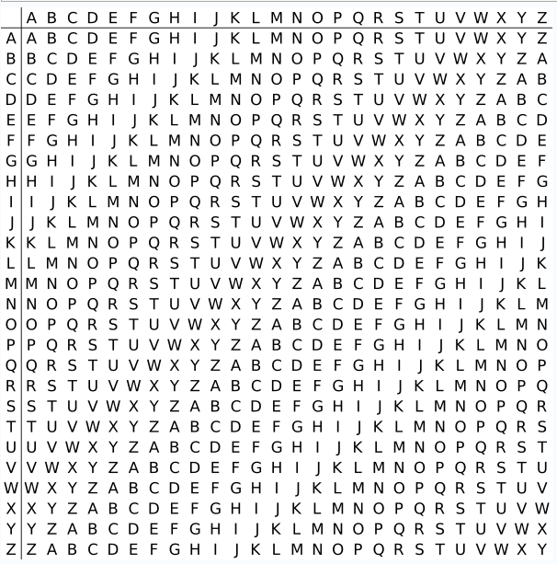

Example Using the Vigenère Table (As in the Picture)
Given
Plaintext: HELLO
Key: KEY
Repeat the key to match plaintext length: KEYKE
To encrypt:
- Use Kᵢ for the row
- Use Pᵢ for the column
- Cᵢ is the letter at the intersection
Step-by-Step Encryption Using the Table
Plaintext (Pᵢ) | Key (Kᵢ) | Row (Key) | Column (Plaintext) | Ciphertext (Cᵢ)
H | K | K | H | R
E | E | E | E | I
L | Y | Y | L | J
L | K | K | L | V
O | E | E | O | S
Result
Ciphertext: RIJVS
To decrypt:
- Use Kᵢ for the row
- Locate Cᵢ in that row
- Pᵢ is the letter at the top of the column
Decryption Steps
Ciphertext (Cᵢ) | Key (Kᵢ) | Row (Key) | Find Cᵢ in Row | Plaintext (Pᵢ)
R | K | K | R | H
I | E | E | I | E
J | Y | Y | J | L
V | K | K | V | L
S | E | E | S | O
Result
Recovered Plaintext: HELLO
16.4 Complete Analysis of Vigenère Cryptanalysis
1. Distribution of Monoalphabetic Frequencies
In the Vigenère cipher:
- Encryption uses multiple monoalphabetic substitution ciphers
- Each cipher corresponds to one key letter
Because of this:
- Overall ciphertext letter frequencies appear distributed
- Simple frequency analysis on the whole ciphertext fails
Monoalphabetic frequencies are distributed
2. Effect of Different Key Letters
Rule 1
Encrypting the same plaintext letter with different key letters produces different ciphertext letters.
Example:
E + A → E
E + D → H
E + T → X
This hides natural language frequency patterns.
Rule 2 (Weakness)
Encrypting the same plaintext letter with the same key letter produces the same ciphertext letter.
So:
Same PT + Same K → Same CT
This creates repeated ciphertext patterns when:
- Plaintext repeats
- Key repeats in the same alignment
d | e | c | e | p | t | i | v | e | d | e | c | e | p | t | i | v | e | d | e | c | e | p | T | i | v | e
w | e | a | r | e | d | i | s | c | o | v | e | r | e | d | s | a | v | e | y | o | u | r | s | e | l | f
Z | I | C | V | T | W | Q | N | G | R | Z | G | V | T | W | A | V | Z | H | C | Q | Y | G | L | M | G | J
1 2 3 4 5 6 7 8 9 10 11 12
3. Repetition Phenomenon (Shown in Diagram)
In the given diagram:
- Key: deceptive (length = 9)
- Plaintext contains repeated segments
- The repeated plaintext segments align with the same key letters
As a result:
- Identical ciphertext segments appear (highlighted in red)
This confirms:
Two identical plaintext sequences occurring at a distance that is an integer multiple of keyword length generate identical ciphertext sequences.
4. Key Length Revelation
- Distance between identical ciphertext segments = multiple of key length
- Observed distances suggest:
  - 3 or 9 as possible key lengths
This step exploits repetition to determine the key length
(Conceptually known as Kasiski examination)
5. Assuming Key Length = 9
Take Factors of the Distance
The distance between repeated sequences is: 9
Possible key lengths are factors of 9: 1, 3, 9
We discard:
- 1 (that would be monoalphabetic)
- 3 (possible but less likely)
9 is the most likely key length.
Once key length is assumed to be 9:
- The cipher effectively uses 9 monoalphabetic ciphers
- Each position modulo 9 uses the same key letter
6. Splitting the Ciphertext into Groups
Ciphertext characters are grouped as:
- Group 1 → positions 1, 10, 19, 28, …
- Group 2 → positions 2, 11, 20, 29, …
- …
- Group 9 → positions 9, 18, 27, …
Each group:
- Was encrypted using the same key letter
- Behaves like a Caesar cipher
7. Individual Frequency Analysis
- Perform frequency analysis separately on each group
- Determine the Caesar shift for each group
- Recover each key letter independently
- Combine recovered letters to obtain the full key
16.5 Example for deciphering (cryptanalysis)
Assume we have already found:
Key length = 3
Ciphertext: L X F O P V E F R N H R
(Index positions shown below)
Position: 1 2 3 4 5 6 7 8 9 10 11 12
Cipher: L X F O P V E F R N H R
Step 1: Understand What Key Length = 3 Means
- The Vigenère cipher is using 3 monoalphabetic ciphers
- Every 3rd letter is encrypted with the same key letter
So we will create 3 groups.
Step 2: Split the Ciphertext into Groups
🔹 Group 1 (positions 1, 4, 7, 10, …)
Positions: 1 4 7 10
Letters: L O E N
Group 1: L O E N
🔹 Group 2 (positions 2, 5, 8, 11, …)
Positions: 2 5 8 11
Letters: X P F H
Group 2: X P F H
🔹 Group 3 (positions 3, 6, 9, 12, …)
Positions: 3 6 9 12
Letters: F V R R
Group 3: F V R R
Step 3: What Have We Achieved?
Now instead of one Vigenère cipher, we have:
- Group 1 → one monoalphabetic (Caesar) cipher
- Group 2 → one monoalphabetic (Caesar) cipher
- Group 3 → one monoalphabetic (Caesar) cipher
Each group:
- Was encrypted using one fixed key letter
- Can be attacked using frequency analysis
Step 4: Apply Frequency Analysis (Conceptually)
For each group:
- Find the most frequent letter
- Assume it maps to E (or another common letter)
- Determine the shift
- Recover the key letter for that group
Do this 3 times → get the full key.

17. Autokey Cipher
1. Introduction
The Autokey cipher is a type of polyalphabetic substitution cipher.
It is a modification of the Vigenère cipher, designed to remove the weakness of a repeating key.
Instead of repeating the keyword again and again, the key is extended using the plaintext itself.
2. Basic Idea
In the Vigenère cipher:
- The key repeats (e.g., KEYKEYKEY…)
In the Autokey cipher:
- Start with a short keyword
- Then add the plaintext to the keyword
- The key becomes as long as the message
This reduces repeating patterns and improves security.
3. Key Construction
Example:
Plaintext: ATTACKATDAWN
Keyword: KEY
Autokey becomes: KEYATTACKAT
(Keyword + plaintext letters until lengths match)

4. Encryption (Using the Vigenère Table)
Rule Using the Table (like your picture):
- Use the key letter as the row
- Use the plaintext letter as the column
- The letter at the intersection is the ciphertext
Example Encryption
Plaintext: ATTACK
Keyword: KEY
Construct Autokey: KEYATT
Now encrypt letter by letter using the table.
Step-by-Step
Plaintext | A | T | T | A | C | K
Key | K | E | Y | A | T | T
Now use the table:
- Row K, Column A → K
- Row E, Column T → X
- Row Y, Column T → R
- Row A, Column A → A
- Row T, Column C → V
- Row T, Column K → D
Ciphertext: KXRAVD
5. Decryption (Using the Table)
Rule Using the Table:
- Use the key letter as the row
- Find the ciphertext letter inside that row
- The column heading gives the plaintext letter
- After recovering plaintext letters, add them to the key
Example Decryption
Ciphertext: KXRAVD
Keyword: KEY
Step-by-Step
First, write initial key letters:
K E Y
1️⃣ Decrypt K with K
- Go to row K
- Find letter K in that row
- Column heading = A
Plaintext = A
2️⃣ Decrypt X with E
- Row E
- Find X
- Column heading = T
Plaintext = T
3️⃣ Decrypt R with Y
- Row Y
- Find R
- Column heading = T
Plaintext = T
Now recovered plaintext = ATT
Extend key using recovered plaintext:
Key becomes:
KEYATT
Continue:
4️⃣ Row A, find A → column A → A
5️⃣ Row T, find V → column C → C
6️⃣ Row T, find D → column K → K
Final plaintext: ATTACK
6. Advantages
- No repeating key pattern
- Harder to detect key length
- More secure than standard Vigenère
7. Disadvantages
- If part of plaintext is guessed, the key can be discovered
- An error in one letter affects further decryption

18. Vernam Cipher and One-Time Pad (OTP)
Vernam Cipher and One-Time Pad (OTP)
The one-time pad, which is a provably secure cryptosystem, was developed by Gilbert Vernam in 1918.
The message is represented as a binary string (a sequence of 0’s and 1’s using a coding mechanism such as ASCII coding).
The key is a truly random sequence of 0’s and 1’s of the same length as the message.
The encryption is done by adding the key to the message modulo 2, bit by bit.
This process is called:
Exclusive OR (XOR)
The symbol used is:
⊕
Example – Vernam Cipher
Message:
0 0 1 0 1 1 0 1 0 1 1 1
Pad (Key):
1 0 0 1 1 1 0 0 1 0 1 1
Cipher (XOR):
1 0 1 1 0 0 0 1 1 1 0 0

Receiving Side
Cipher:
1 0 1 1 0 0 0 1 1 1 0 0
Pad:
1 0 0 1 1 1 0 0 1 0 1 1
XOR again:
Recovered message:
0 0 1 0 1 1 0 1 0 1 1 1
Because:
XORing twice with the same key returns the original message.
Example (Hex / Binary Form)
Plaintext:
F8
Key:
47
Binary representation:
Plaintext:
1111 1000
Key:
0100 0111
Cipher (XOR):
1011 1111
Which equals:
BF
Analysis of OTP
Given the ciphertext:
ANKYODKYUREPFJBYOJDSPLREYIUNOFDOIUERFPLUYT
Suppose attacker finds two different keys:
K1 produces:
mr mustard with the candlestick in the hall
K2 produces:
miss scarlet with the knife in the library
Which one is correct?
The attacker cannot determine.
Because:
- Both keys are random
- Both plaintexts are meaningful
- Ciphertext gives no statistical clue
Mathematical Form (as in slides)
To encrypt n plaintext bits:
Ci = (pi ⊕ ki)
To decrypt n ciphertext bits:
pi = (Ci ⊕ ki)
There is no statistical relationship between plaintext and ciphertext.

Conditions for Perfect Security
For OTP to be secure:
- Key must be truly random.
- Key must be same length as message.
- Key must never be reused.
- Key must remain secret.
If key is reused → security breaks.

Rotor Machine Encryption
Video link: ( https://youtu.be/TjaKCfSng-4?si=GicNuPgVEhWPFLmJ ) -> Is vid me rotor wheel ka concept plus rotation wala concept explained hai.
1. Definition
A rotor machine is a mechanical or electro-mechanical encryption device that implements a polyalphabetic substitution cipher using rotating wheels called rotors. Each rotor performs a permutation (rearrangement) of input symbols. Because the rotors rotate after each key press, the substitution changes continuously. This makes the cipher dynamic and much stronger than a simple substitution cipher. A famous historical example is the Enigma machine.
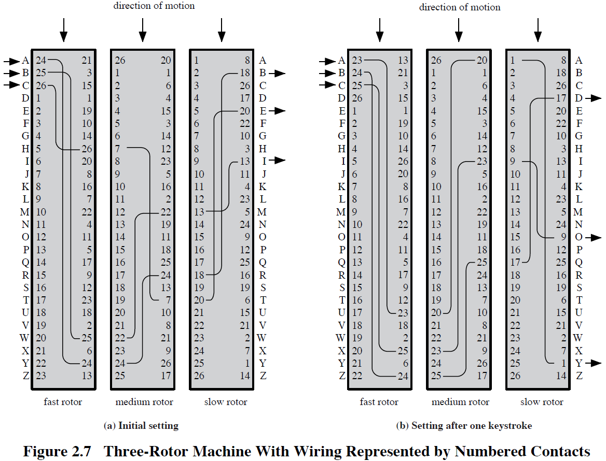
2. Basic Structure of a Rotor Machine
A typical rotor system consists of:
- Fast rotor (rightmost rotor)
- Medium rotor (middle rotor)
- Slow rotor (leftmost rotor)
Each rotor contains:
- Input contacts (in your picture: numbers 0–5)
- Output contacts (0–5)
- Internal wiring that connects each input to exactly one output
Important property:
Each rotor performs a one-to-one mapping (permutation). No two inputs produce the same output.
In the real system there are 26 letters. In your picture there are 6 symbols (A–F), which simplifies understanding.
3. Concept of Working
Let:
- R1 = Fast rotor
- R2 = Medium rotor
- R3 = Slow rotor
Encryption of one letter is:
C = R3(R2(R1(P)))
Where:
- P = plaintext
- C = ciphertext
After every key press:
- Fast rotor rotates by one position.
- After completing one full rotation, the medium rotor rotates by one position.
- After the medium completes a full rotation, the slow rotor rotates.
This stepping mechanism ensures that the substitution function changes continuously.
4. Understanding the Given Picture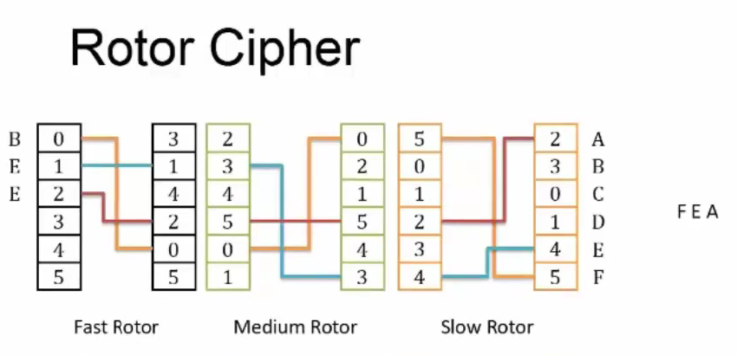
The picture shows a simplified 3-rotor system using 6 symbols:
A = 0
B = 1
C = 2
D = 3
E = 4
F = 5
Plaintext entered: B E E
Ciphertext obtained: F E A
We now trace the encryption step by step.
5. Detailed Step-by-Step Example Using the Picture
Encryption of First Letter: B
B corresponds to 1.
Step 1: Through Fast Rotor
From the wiring shown in the image:
1 → 1
Output becomes 1.
Step 2: Through Medium Rotor
1 → 3
Output becomes 3.
Step 3: Through Slow Rotor
3 → 5
5 corresponds to F.
Therefore:
B → F
Encryption of Second Letter: E
Before encrypting the second letter, the fast rotor rotates by one position.
Because the rotor rotates, its alignment changes. The wiring remains the same internally, but the mapping relative to the input changes.
Now encrypt E (which is 4).
After passing through the updated fast rotor, medium rotor, and slow rotor (as shown in the image tracing), the output becomes 4.
4 corresponds to E.
Therefore:
E → E
Encryption of Third Letter: E
Again, before encryption, the fast rotor rotates one more step.
The mapping changes again.
Now encrypt E (4).
After passing through all three rotors with the new alignment, the output becomes 0.
0 corresponds to A.
Therefore:
E → A
Final Result:
Plaintext: B E E
Ciphertext: F E A
6. Why Same Letter Produces Different Outputs
In this example:
The letter E appeared twice.
First E → E
Second E → A
This happens because:
- The fast rotor rotated between the two encryptions.
- The effective substitution changed.
- Even though the wiring is fixed, the position shift changes the mapping.
This property makes the rotor cipher polyalphabetic.
7. Mathematical Interpretation
Each rotor performs a permutation over the set {0,1,2,3,4,5}.
If rotor position is represented as an offset k, then the effective mapping becomes:
Output = R((Input + k) mod 6) - k mod 6
Because k changes after every key press, the function changes.
Total substitution at any moment is the composition of three permutations:
E = R3 ∘ R2 ∘ R1
After each key press:
R1 position increases.
Therefore, encryption function is not constant.
8. Security Advantage
In a simple substitution cipher:
A always maps to the same letter.
In a rotor cipher:
A maps differently each time because the rotor position changes.
This prevents simple frequency analysis from working effectively.
With 3 rotors and 26 letters:
Total possible rotor positions = 26 × 26 × 26 = 17576
This does not even include different rotor wirings or starting configurations.

